**Comment, Variables, Input & Output in Shell Scripting**

**Comment**

* Create a .sh file

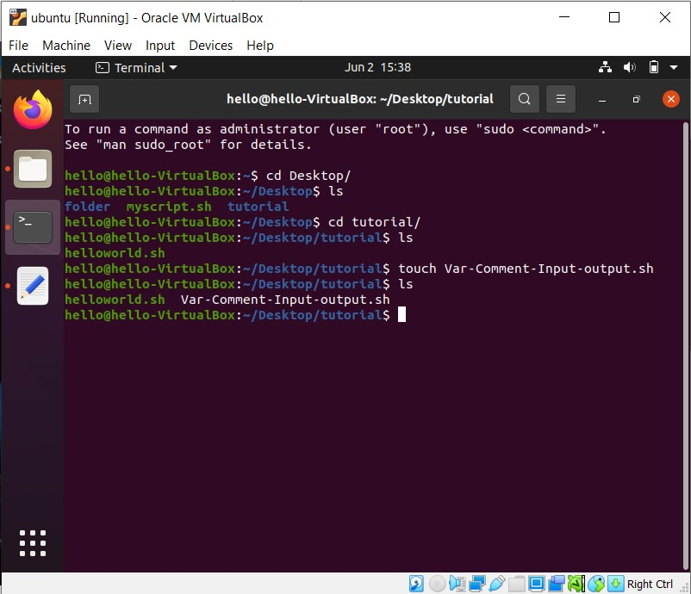

* Open a .sh file and we write the comment and script in our file

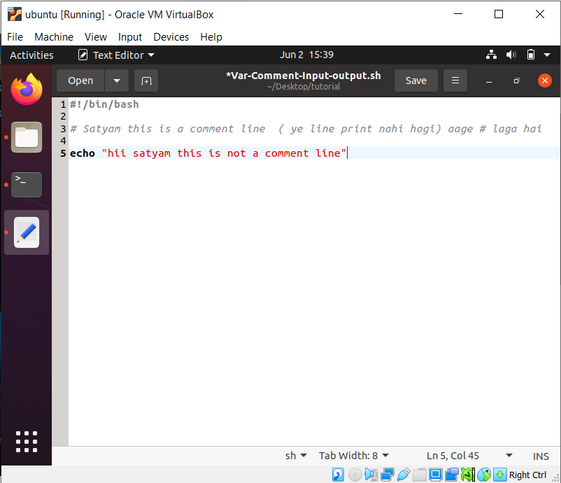

* We have not a permission to execute this file.

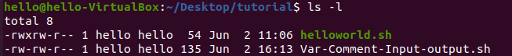

* We use this command to got a permission & execute this file .

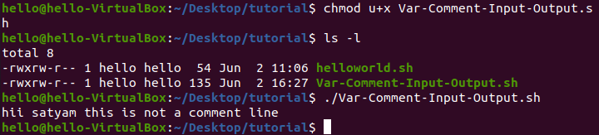

**Variables**

* In linux shell script we don’t need to define which type of variable we use it , like int, float, char
* In Shell Script we not give any type of space when we declare var

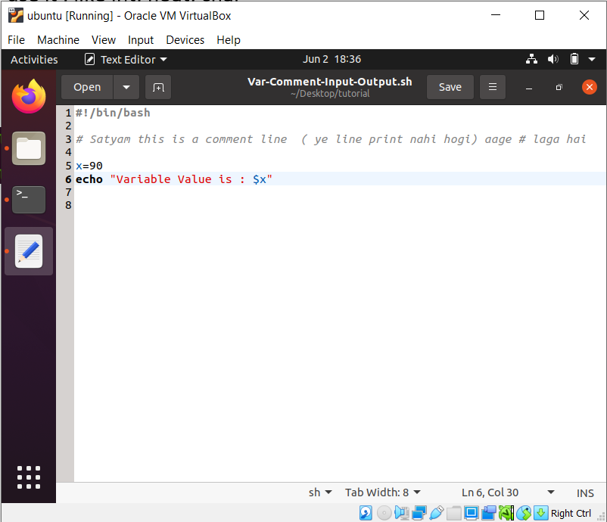

* Check file status



* If we want to change variable value we change like this way:-

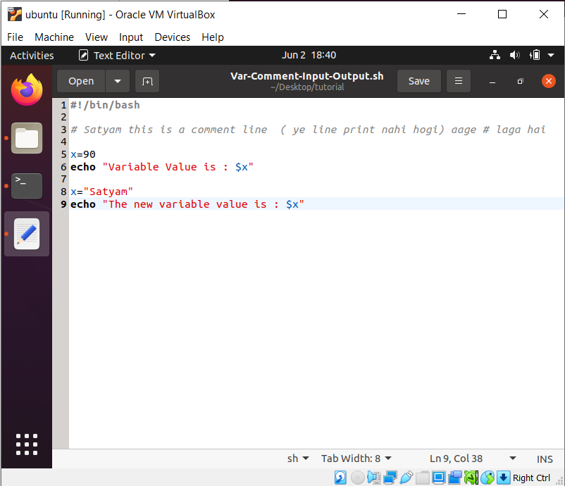

* Check file status

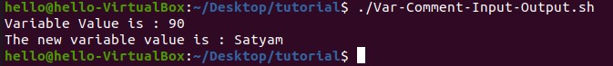

**User’s Input**

* **If I want ask to user to fill details so we write this script**

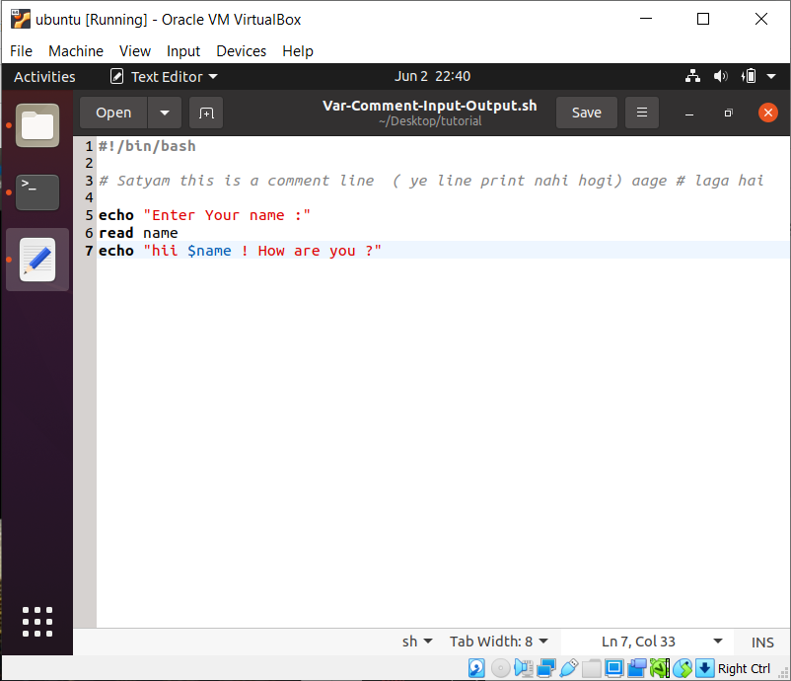

* **Check file Status**

